Face recognition with open cv deep learning models

*By*

Sanath Singavarapu with Reg No:188

Musale Krushna Pavan with Reg No:150



*Bachelor Thesis submitted to*

Indian Institute of Information Technology Kalyani

*for the partial fulfillment of the degree of*

**Bachelor of Technology**

**in**

**Computer Science and Engineering/Information Technology**

**May 2018**

Certificate

This is to certify that the thesis entitled “Face recognition with open cv deep learning models” being submitted by Sanath Singavarapu and Musale Krushna Pavan, an undergraduate student, Reg. No: 188 and 150, in the Department of Computer Science and Information Engineering, Indian Institute of Information Technology Kalyani, West Bengal 741235, India, for the award of Bachelor of Technology in Computer Science and Information Engineering /Information Technology is an original research work carried by him under my supervision and guidance. The thesis has fulfilled all the requirements as per the regulations of Indian Institute of Information Technology Kalyani and in my opinion, has reached the standards needed for submission. The work, techniques and the results presented have not been submitted to any other University or Institute for the award of any other degree or diploma.

Dr. Dalia Nandi Das,

Faculty

Electronics Department

Declaration

I hereby declare that the work being presented in this thesis entitled, “Face recognition with open cv deep learning models”, submitted to Indian Institute of Information Technology Kalyani in partial fulfillment for the award of the degree of **Bachelor of Technology** in Computer Science and Engineering during the period from Jan, 2019 to May, 2019 under the supervision of Dr. Dalia Nandi Das, Department of Computer Science and Engineering, Indian Institute of Information Technology Kalyani, West Bengal 741235, India, does not contain any classified information.

Name of the Candidate: Sanath Singavarapu, Musale Krushna Pavan.

Reg No/Roll No:188,150.

Name of the Department: Computer Science and Engineering.

Institute Name: Indian Institute of Information Technology Kalyani

This is to certify that the above statement made by the candidate is correct to the best of my knowledge.

..................................

Dr. Dalia Nandi Das,

Faculty

Electronics Department

Place: Kalyani

Date:

Acknowledgments

First of all, I would like to take this opportunity to thank my supervisor ……………………………

Name of the Candidate: Sanath Singavarapu, Musale Krushna Pavan.

Reg No/Roll No: 188, 150.

Name of the Department: Computer Science and Engineering.

Institute Name: Indian Institute of Information Technology Kalyani

Place: Kalyani.

Date:

Table of Contents:

1. Introduction

2. Different modules and open sources used

-Detecting the face - CAFE model

-Training the Model - Open face model

-Recognizing the face from the live stream - SVM

-Authenticating the persons

4. Flow Diagram

5. The theory behind the work

6. Applications and Future Work

7. References

Introduction

The main motive of the project is to develop a face recognition model that uses input from any live stream camera and recognize the persons in the video camera.

First, we will use an Face Detection – CAFE model to detect the face of the person from the input video stream from any camera.

We will crop the face and convert into 128D vector .

We will use this vectors to train our model and make it to recognize the particular person with his name.

At the end we will recognize the person with the help of support vector machine algorithm in machine learning.

This is the simple and faster way to recognize faces from the live stream with a grater accuracy.

Algorithm

1. Detect faces in image using pre-trained models that are compatible with [OpenCV](http://docs.opencv.org/master/tutorial_py_face_detection.html).
2. Transform the face for the neural network. This repository uses dlib's [real-time pose estimation](http://blog.dlib.net/2014/08/real-time-face-pose-estimation.html) with OpenCV's [affine transformation](http://docs.opencv.org/doc/tutorials/imgproc/imgtrans/warp_affine/warp_affine.html) to try to make the eyes and bottom lip appear in the same location on each image.
3. Use a deep neural network to represent (or embed) the face on a 128-dimensional unit hypersphere. The embedding is a generic representation for anybody's face. Unlike other face representations, this embedding has the nice property that a larger distance between two face embeddings means that the faces are likely not of the same person. This property makes clustering, similarity detection, and classification tasks easier than other face recognition techniques where the Euclidean distance between features is not meaningful.
4. Extracting information from the face and applying augmentation techniques for better real-time performance.
5. Apply your favourite clustering or classification techniques to the features to complete your recognition task. We are using Support Vector Machines(SVM) in our model. See below for our examples for classification and similarity detection, including an online web demo.
6. Marking out the detected faces from the image and labelling them.

Different modules and open sources used

* Detecting the face - CAFE model
* Encoding the image into 128-D Vectors - Open face model
* To Train the model and to classify the image-SVM
* Recognize the image which are trained by our dataset and labelling rest as unknown

**Face Detection – CAFE model**

Caffe is a deep learning framework made with expression, speed, and modularity in mind. It is developed by Berkeley AI Research ([BAIR](http://bair.berkeley.edu/)) and by community contributors. [Yangqing Jia](http://daggerfs.com/) created the project during his PhD at UC Berkeley. Caffe is released under the [BSD 2-Clause license](https://github.com/BVLC/caffe/blob/master/LICENSE).

Why Caffe?

**Expressive architecture** encourages application and innovation. Models and optimization are defined by configuration without hard-coding. Switch between CPU and GPU by setting a single flag to train on a GPU machine then deploy to commodity clusters or mobile devices.

**Extensible code** fosters active development. In Caffe’s first year, it has been forked by over 1,000 developers and had many significant changes contributed back. Thanks to these contributors the framework tracks the state-of-the-art in both code and models.

**Speed** makes Caffe perfect for research experiments and industry deployment. Caffe can process **over 60M images per day** with a single NVIDIA K40 GPU*. That’s 1 ms/image for inference and 4 ms/image for learning and more recent library versions and hardware are faster still. We believe that Caffe is among the fastest convnet implementations available.

Encoding into 12D vector – open face model

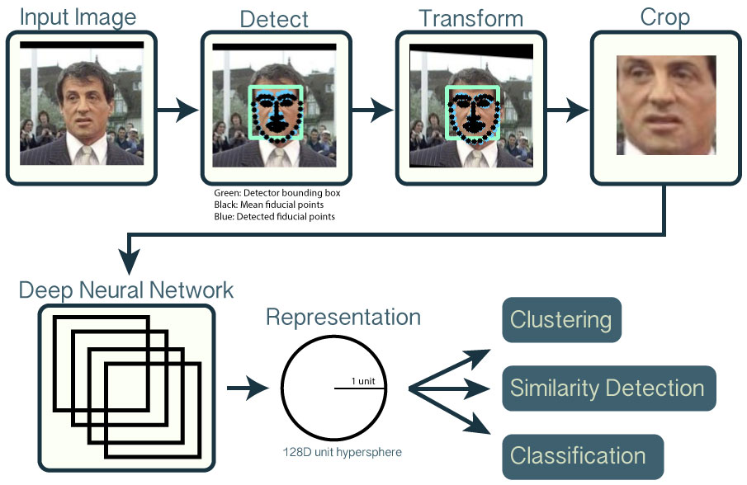

**Recognize – SVM**

In machine learning, **support-vector machines** (**SVMs**, also **support-vector networks**) are supervised learning models with associated learning algorithms that analyse data used for classification and regression analysis.

Given a set of training examples, each marked as belonging to one or the other of two categories, an SVM training algorithm builds a model that assigns new examples to one category or the other, making it a non-probabilistic binary linear classifier (although methods such as Platt scaling exist to use SVM in a probabilistic classification setting). An SVM model is a representation of the examples as points in space, mapped so that the examples of the separate categories are divided by a clear gap that is as wide as possible. New examples are then mapped into that same space and predicted to belong to a category based on which side of the gap they fall

Flow chat

Advantages and Future Improvement

**Mobile phone makers in products:**

Apple first used facial recognition to unlock its iPhone X, and continues with the iPhone XS. Face ID authenticates — it makes sure you’re you when you access your phone. Similarly we can also use our algorithm for it.

**Automate the attendance system**

You might be accustomed to having an agent scan your boarding pass at the gate to board your flight. At least one airline scans your face.

**Catching the criminals**

Police can combine surveillance cameras and facial recognition to scan the faces of people. One goal: identifying suspicious characters and criminals

References:

1. <https://us.norton.com/internetsecurity-iot-how-facial-recognition-software-works.html>
2. <https://en.wikipedia.org/wiki/Support-vector_machine>
3. https://caffe.berkeleyvision.org/